***PAAREES PERFUMES***

***CALVIN KLIEN***

***FOR MEN***

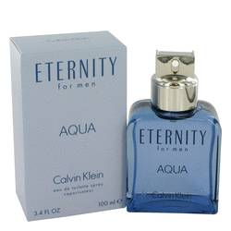

# 

***ELERNITY AQUA***

## *Description:*

Eternity Aqua by Calvin Klein Cologne. The Eternity line from Calvin Klein was elevated in 2010 when the company introduced Calvin Klein Eternity Aqua for men. This fresh, cool scent features citrus notes blended with lotus, lavender and cucumber, with selected green notes mingled in for added rejuvenation. Just a splash of Eternity Aqua in the morning lasts all day. Choose this fragrance when you want to exude confidence as well as show those around you that you love the finer things in life.